Assignment 4.1
K. Shiva Teja
2303A52480
Batch: 44
Problem Statement 1: Customer Email Classification.
Task 1:
- billing@company.com – Billing category
- support@company.com – Support category
- feedback@compay.com – Feedback category
- info@company.com – Others category
- no-reply@company.com – Others Category

Task 2:
Prompt:
Classify the following customer email into one of these categories:
Billing, Technical Support, Feedback, Others.
Email: "I was charged twice for my monthly subscription"

Task 3:
Prompt:
Email: "The app is not working properly"
Category: Technical Support
Now classify the following email:
Email: "My payment failed but the amount was deducted"

Task 4:
Prompt 1:
Email: "Payment failed during checkout"
Category: Billing
Prompt 2:
Email: "App crashes on startup"
Category: Technical Support
Prompt 3:
Email: "Excellent customer service"
Category: Feedback
Now classify the following email:
Email: "I was charged twice for my monthly subscription"

Task 5:
Code: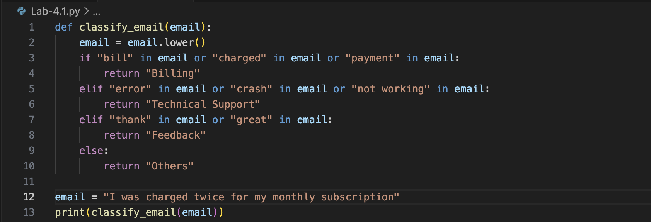
Output:
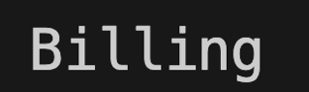

Brief Comments
- Zero-shot prompting works without examples but may misclassify emails when the content is ambiguous.
- One-shot prompting improves understanding by providing one example, leading to better classification.
- Few-shot prompting gives the best results because multiple examples clearly define category boundaries, resulting in higher accuracy and confidence.
Observation
Few-shot prompting is the most effective technique for customer email classification, followed by one-shot, while zero-shot is the least reliable.
Problem Statement 2: Intent Classification for Chatbot Queries
Task 1:
Query ID | User Query | Intent
Q1 | I am unable to log in to my account | Account Issue
Q2 | Where is my order right now? | Order Status
Q3 | What features does this product offer? | Product Inquiry
Q4 | What are your customer support hours? | General Question
Q5 | I forgot my account password | Account Issue
Q6 | How much does this product cost? | Product Inquiry

Task 2:
Prompt:
Classify the following user query into one of these intents:
Account Issue, Order Status, Product Inquiry, General Question.
Query: "Where is my order right now?"
Task 3:
Prompt:
Query: "I am unable to log in to my account"
Intent: Account Issue
Now classify the following query:
Query: "Where is my order right now?"

Task 4:
Prompt 1:
Query: "I forgot my password"
Intent: Account Issue
Prompt 2:
Query: "Track my shipment"
Intent: Order Status
Prompt 3:
Query: "What are your working hours?"
Intent: General Question
Now classify the following query:
Query: "Where is my order right now?"

Task 5:
Prompting Technique | Accuracy | Reliability | Observation
Zero-shot | Medium | Low | Works for clear queries but struggles with ambiguity
One-shot | High | Medium | Better intent understanding with one example
Few-shot | Very High | High | Most accurate and consistent results

Observation
Few-shot prompting is the most effective technique for chatbot intent classification as it provides sufficient context and reduces ambiguity, followed by one-shot prompting. Zero-shot prompting is the least reliable.

Problem Statement 3: Student Feedback Analysis
Task A:
Prompt:
A zero-shot prompt classifies sentiment without giving any examples.
Prompt:
“Classify the sentiment of the following student feedback as Positive, Negative, or Neutral.
Feedback: The lectures were informative but sometimes rushed.”

Task B:
One-shot Prompt
A one-shot prompt provides one example before classification.
Prompt:
“Classify the sentiment of the student feedback as Positive, Negative, or Neutral.
Example:
Feedback: The professor explains concepts very clearly.
Sentiment: Positive
Now classify this feedback:
The lectures were informative but sometimes rushed.”

Task C:
Few-shot Prompt
A few-shot prompt provides multiple labeled examples.
Prompt:
“Classify the sentiment of student feedback as Positive, Negative, or Neutral.
Examples:
Feedback: The course content was very engaging and helpful.
Sentiment: Positive
Feedback: The assignments were confusing and poorly explained.
Sentiment: Negative
Feedback: The syllabus covered all required topics.
Sentiment: Neutral
Now classify this feedback:
The lectures were informative but sometimes rushed.”

Task D:
How examples improve sentiment classification accuracy
Examples help the model understand the meaning of each sentiment category.
They reduce confusion in mixed or unclear feedback.
They provide context and tone for correct classification.
They improve consistency in predictions.

Problem Statement 4: Course Recommendation System

Task A:
Zero-shot Prompt:
A zero-shot prompt classifies the learner’s query without providing any examples.
Prompt:
“Classify the following learner query as Beginner, Intermediate, or Advanced.
Query: I want to learn machine learning from scratch.”

Task B:
One-shot Prompt
A one-shot prompt provides one labeled example before classification.
Prompt:
“Classify the learner query as Beginner, Intermediate, or Advanced.
Example:
Query: I have no programming experience and want to learn Python.
Level: Beginner
Now classify this query:
I want to learn machine learning from scratch.”

Task C:
Few-shot Prompt
A few-shot prompt provides multiple labeled examples to guide classification.
Prompt:
“Classify the learner query as Beginner, Intermediate, or Advanced.
Examples:
Query: I am new to programming and want to understand basic coding concepts.

Query: I know Python and want to build machine learning models.
Level: Intermediate
Query: I want to optimize deep learning models for real-world applications.
Level: Advanced
Now classify this query:
I want to learn machine learning from scratch.”

Task D:
How Few-shot prompting improves recommendation quality?
- Few-shot examples clearly define each learning level.
- They reduce ambiguity in learner queries.
- The model better understands skill differences between levels.
- Recommendations become more accurate and relevant.
- Consistent classification leads to better course suggestions.

Problem Statement 5: Social Media Post Moderation

Task A:
Zero-shot Prompt
A zero-shot prompt classifies a post without providing any examples.
Prompt:
“Classify the following social media post as Acceptable, Offensive, or Spam.
Post: Buy this product now! Limited offer!!!”

Task B:
One-shot Prompt
A one-shot prompt provides one labeled example before classification.
Prompt:
“Classify the social media post as Acceptable, Offensive, or Spam.
Example:
Post: This app is really helpful and easy to use.
Category: Acceptable
Now classify this post:
Buy this product now! Limited offer!!!”

Task C:
Few-shot Prompt
A few-shot prompt provides multiple labeled examples to guide classification.
Prompt:
“Classify the social media post as Acceptable, Offensive, or Spam.

Examples:
Post: Great content, very informative!
Category: Acceptable
Post: You are stupid and useless.
Category: Offensive
Post: Click here to win a free phone now!
Category: Spam
Now classify this post:
Buy this product now! Limited offer!!!”

Task D:
Challenges of Zero-shot prompting in content moderation
- The model may misunderstand the context of the post.
- It can struggle with sarcasm or indirect offensive language.
- There is higher risk of misclassification without examples.
- Spam and offensive content may look similar in some cases.
- Overall accuracy is lower compared to one-shot or few-shot prompting.

